|  |  |
| --- | --- |
| titelblad_voorstel.png | |
| MOTOYO  Linux Hosting Project | |
| Team 2 – Pieter Moons, Tommy Fonken,  Yordi Philips | Bachelor electronica-ICT  Option: Cloud and Cyber Security |
|  |

Preface

Welcome to our project, specially created for bloggers! As ICT students, we deeply understand the importance of providing a reliable and efficient platform for bloggers to express their thoughts and ideas online. That's why we embarked on a journey to develop a Linux server hosting service tailored specifically for bloggers.

Our primary objective is to offer bloggers a seamless experience, enabling them to focus on creating outstanding content. By harnessing the flexibility, stability, and security of Linux, we aim to provide an optimal environment for bloggers to flourish.

Throughout this project, we will delve into various aspects of Linux server hosting for bloggers. We will cover topics such as setup, optimizing performance, implementing robust security measures, and incorporating additional features to enhance the overall blogging experience. Our goal is to deliver a user-friendly and intuitive platform, leveraging the latest technologies and industry best practices.

Ultimately, our project seeks to empower bloggers to unlock their full potential and leave a lasting impact in the digital realm. We invite you to join us on this exciting journey as we explore the captivating world of Linux server hosting for bloggers. Together, we will revolutionize the way ideas are shared, connections are made, and the future of online content creation is shaped.

We want to thank everyone who has supported us throughout this journey. Our mentors, professors, and the entire Thomas More have given us valuable advice and guidance. We also want to thank our readers, whose interest and enthusiasm have inspired us every step of the way.

Sincerely,

Pieter Moons

Tommy Fonken

Yordi Philips

Inhoudsopgave

[1 Introduction 2](#_Toc136536561)

[2 Technical Description 3](#_Toc136536562)

[2.1 Diagram 3](#_Toc136536563)

[2.2 System components 3](#_Toc136536564)

[2.2.1 Django backend 3](#_Toc136536565)

[2.2.2 User interface Full website 3](#_Toc136536566)

[2.2.3 Django Components 8](#_Toc136536567)

[2.2.4 Key Features used of Django 13](#_Toc136536568)

[2.3 Software 15](#_Toc136536569)

[3 Manual 16](#_Toc136536570)

[4 Troubleshooting 17](#_Toc136536571)

[5 tools 18](#_Toc136536572)

[6 Conclusion…. 19](#_Toc136536573)

[7 Attachments 20](#_Toc136536574)

[8 Reference List 21](#_Toc136536575)

# Introduction

We, three students, have taken up the challenge of creating a project on Linux hosting services. Our project aims to provide a detailed technical description, a user-friendly guide explaining how everything works, troubleshooting steps for potential issues, and an overview of the tools utilized in the project.

In this project, we delve into the intricate details of Linux hosting services, offering step-by-step instructions on setup and configuration. Our primary goal is to provide a seamless user experience by explaining the hosting service's functionality effectively. We also address common problems that may occur and provide practical troubleshooting techniques to resolve them.

Furthermore, we showcase the various tools we utilized throughout the project, emphasizing their importance in enhancing performance, security, and overall functionality. By providing an in-depth overview of these tools, we aim to equip readers with valuable knowledge and empower them to make informed decisions.

We are enthusiastic about presenting this project as a valuable resource for individuals seeking to understand the technical aspects of Linux hosting services. Through extensive research, thorough testing, and hands-on experience, we strive to offer practical insights and guidance that can be readily applied in real-world scenarios.

We genuinely hope that our project will serve as a valuable reference for those interested in Linux hosting services, providing them with the confidence and knowledge needed to navigate the complexities of managing a robust hosting environment.

# Technical Description

## Diagram

|  |
| --- |
| A diagram of a computer  Description automatically generated with medium confidence  Figure 1: Diagram environment |

Because our production environment resides in a closed datacentre, our customers will have to connect to the firewall using a VPN. This firewall is maintained by the IT-staff of Thomas More Campus Geel.

When a user wants to deploy a lamp stack or a WordPress instance. He needs to go to the main site of Motoyohosting: https://www.motoyohosting.uk. There he has the option to register an account, perform a login and create a hosting instance. This is made possible using the Django framework running on our webserver. The framework checks if all required fields off the form are filled in and if the chosen hostname does not already exist.

Then it launches a script that executes a sequence of API calls to the Rancher-server. The rancher server is the server managing our Kubernetes cluster. This cluster is made up of five nodes, two of them hold the control plane role and three of them the worker role.

Those API calls will start a series of tasks on the Rancher-server. They will make sure all the required services are made available to host the deployment chosen by the customer.

When the API calls have been executed without returning errors. The client will be notified by a message on the hosting webpage. This message contains the URL’s and ports the customer needs to configure his website or blog.

We provisioned a VM to host services like DNS, LDAP and the Puppetmaster.

In the next chapters we will discuss all the elements mentioned above in more detail.

## System components

### vCenter environment

To create our environment, we had the opportunity to make use of the existing vCenter infrastructure of the IT Factory of Thomas More.

vCenter is a centralized management software developed by VMware, a leading virtualization technology company. It is a key component of VMware's vSphere suite, which provides a comprehensive virtualization platform for building and managing virtualized environments.

vCenter serves as a centralized management tool for virtual infrastructure, enabling administrators to efficiently manage and control multiple virtual machines (VMs) and hosts from a single interface. It provides a wide range of features and capabilities that simplify the management of virtualized environments, including:

1. VM Management: vCenter allows administrators to create, deploy, and manage VMs across multiple hosts. It provides features such as cloning, snapshotting, and template creation to streamline VM management tasks.
2. Resource Management: With vCenter, administrators can allocate and monitor computing resources (CPU, memory, storage, and network) for VMs and hosts. It offers resource pooling and load balancing capabilities to ensure optimal utilization and performance.
3. High Availability and Fault Tolerance: vCenter enables administrators to configure and manage features like High Availability (HA) and Fault Tolerance (FT) for VMs. These features ensure continuous availability and automatic VM failover in case of host failures.
4. Performance Monitoring: vCenter provides comprehensive performance monitoring and reporting capabilities. It allows administrators to track key performance metrics, identify bottlenecks, and troubleshoot performance issues in the virtual infrastructure.
5. Centralized Security and Access Control: vCenter offers robust security features, including user authentication, role-based access control (RBAC), and granular permissions. Administrators can define user roles and assign privileges to ensure secure access to virtual resources.
6. Virtual Networking: vCenter supports virtual networking components like virtual switches and distributed switches. It allows administrators to configure and manage networking settings for VMs and hosts, enabling seamless communication within the virtual environment.

By centralizing the management of virtualized infrastructure, vCenter helps organizations achieve higher efficiency, improved resource utilization, and simplified administration in their virtualized environments. (VMware, Inc. , 2018)

The image and table below show our working environment in the vCenter infrastructure.

|  |
| --- |
| Figure 2: vCenter working environment |

|  |  |
| --- | --- |
| **VM** | **Purpose** |
| CP1 | Control plane node Kubernetes cluster |
| CP2 | Control plane node Kubernetes cluster |
| W1 | Worker Node Kubernetes cluster |
| W2 | Worker Node Kubernetes cluster |
| Services | DNS / LDAP / Puppet |
| Webserver | Django framework |
| Rancher | Software for orchestration & monitoring of Kubernetes cluster |

Table 1: VMs vCenter

### VM template

All the VMs mentioned in the table above are based on a template VM we created in advance.

To create a template, first you have to deploy a VM with an Operating System and the hardware specifications of your choice. When the installation is complete updating & upgrading the OS is the next step. And finally, you must install all the required software & dependencies like SSH, anti-virus, ... This way you don’t have to perform these tasks every time you deploy a new VM. The image below shows the hardware specifications of the VM template we created.

|  |
| --- |
| Afbeelding met tekst, schermopname, software, Webpagina  Automatisch gegenereerde beschrijving  Figure 3: VM template specs |

To preserve resources on the vCenter infrastructure we configured the template with the bare minimum memory & CPU settings (4GB & 2vCPU). The hard disk is created using thin provisioning. This means that the hard disk grows dynamically. The 128GB is the maximum space the VM can occupy on hard disks of the physical server. These hard disks are configured in a RAID 10. The OS of our choice is Ubuntu Server 22.04.2 LTS.

LTS or ‘Long Term Support’ releases are published every two years in April. LTS releases are the ‘enterprise grade’ releases of Ubuntu and are used the most. An estimated 95% of all Ubuntu installations are LTS releases.

|  |
| --- |
| Afbeelding met tekst, schermopname, diagram, Lettertype  Automatisch gegenereerde beschrijving  Figure 4: LTS Ubuntu |

(Canonical Ltd. Ubuntu, 2023)

As you can see on the chart above, the 22.04 LTS release will receive security updates until 2032. Assuring us that we will not have to perform a major upgrade in the near future.

#### Securing the template

To secure access to our VMs we installed the OpenSSH tool and adapted the configuration to our needs.

OpenSSH is the premier connectivity tool for remote login with the SSH protocol. It encrypts all traffic to eliminate eavesdropping, connection hijacking, and other attacks. In addition, OpenSSH provides a large suite of secure tunnelling capabilities, several authentication methods, and sophisticated configuration options. (OpenSSH , 2023)

On the next page is a screenshot of the content of the “/etc/ssh/sshd\_conf” configuration file. Here we changed the default port SSH listens to from 22 to 9871, disabled login with passwords, disabled login with root credentials en enabled the authentication with public keys. We then generated a public key on a windows host and added it to the authorized key file on the template server. This type of configuration makes it very difficult to compromise our VMs.

|  |
| --- |
| Figure 5: sshd\_config file |

The commands we use to create the RSA key and deploy it to the template VM are listed below.

|  |  |  |  |
| --- | --- | --- | --- |
| **Seqnr.** | **where?** | **command** | **What does it do?** |
| 1. | Server | sudo apt install ssh | Installl openssh tool |
| 2. | Server | service ssh status | Check status ssh |
| 4. | Mgt ws | ssh-keygen -t rsa -b 4096 -C your\_email@domain.com | Create rsa\_key.pub on management workstation |
| 5. | Mgt ws linux | ls ~/.ssh/ | Check if ssh key is created |
| 6. | Mgt ws linux | ssh-copy-id xxx.xxx.xxx.xxx | Copy public key to server |
| 7. | Mgt ws windows | type $env:USERPROFILE\.ssh\id\_rsa.pub | ssh [IP of server]" cat >> .ssh/authorized\_keys" | Copy public key to server, is added to authorized-keys file |
| 8. | Mgt ws linux | chmod 600 ~/.ssh/id\_rsa  chmod 644 ~/.ssh/id\_rsa.pub | Set permissions on the mgt ws .ssh directory (only linux) |
| 9. | server | chmod 700 ~/.ssh  chmod 644 ~/.ssh/authorized\_keys | Set permissions on the server .ssh directory |

After applying the configuration, it was only possible to connect to the server using public certificates. We use secureCRT as SSH-client. It has user friendly interface and has the capability to organise all your SSH-connections in a tree structure. It even made it easy to configure a template connection. Which we can copy and adjust the variable parameters.

|  |
| --- |
| Afbeelding met tekst, schermopname, software, Multimediasoftware  Automatisch gegenereerde beschrijving  Figure 6: secureCRT Tree  Afbeelding met tekst, schermopname, software, Webpagina  Automatisch gegenereerde beschrijving  Figure 7: SecureCRT session-config |

To ensure that our servers are free of malware we installed ClamAV on the template and made sure it was UpToDate.

ClamAV is an open-source antivirus software designed to detect and remove various types of malware, including viruses, trojans, worms, and other malicious software. The name "ClamAV" stands for Clam AntiVirus. Originally developed for Unix-like operating systems, ClamAV has gained popularity due to its effectiveness, ease of use, and availability across multiple platforms, including Windows, macOS, and Linux. It is primarily used as a server-side solution, protecting email servers, file servers, and web servers from malware threats. ClamAV utilizes a combination of signature-based detection and heuristic analysis to identify and quarantine malicious files. Signature-based detection involves comparing files against a database of known malware signatures. Heuristic analysis, on the other hand, involves examining file structures, behaviour patterns, and other characteristics to identify potentially malicious code. One of the key advantages of ClamAV is its ability to detect both known and unknown threats. It benefits from a large and active community that contributes to its malware signature database, ensuring regular updates to keep up with emerging threats. (ClamAV, 2023)

To ensure the future configuration would be consistent throughout our environment we preinstalled the puppet-agent software on the template. Making it easier to deploy the configuration management tool in the future. Because Puppet relies on TLS to secure the connections between the Puppetmaster and the Puppet clients. We had to make sure that the time on all the machines was the same. For this reason, we configured the NTP service in the template and added a wide range of public NTP servers.

#### Template network settings

The default setting of Ubuntu is to configure all installed vNICS to use DHCP to obtain an IP address and various options. We noticed that when we deployed a new VM from the template they always had the same IP address as the template VM. Causing problems in the network caused by duplicate addressing. We had to connect to each VM using the “remote connection” in the browser and manually renew the IP lease to overcome this problem. A better solution is to change a line of configuration in the Netplan configuration file.

|  |
| --- |
| Figure 8: Template Netplan |

We forced the DHCP server to look at the virtual MAC address of the vNIC and supply us with a unique IP address in the Virtual Network.

Using this template, we can deploy an up2date VM with the basic software and configuration preinstalled in a couple of minutes.

### Kubernetes

When searching for a solution how to setup our hosting environment. We agreed that we had to containerize the deployments for our customers and were searching for an orchestration tool to manage all these deployments. This led us to Kubernetes.

Kubernetes is an open-source container orchestration platform that automates the deployment, scaling, and management of containerized applications. It was originally developed by Google and is now maintained by the Cloud Native Computing Foundation (CNCF). Kubernetes provides a robust and scalable framework for managing containerized workloads across a cluster of machines.

The core concept in Kubernetes is the notion of a "pod," which is the smallest and most basic unit of deployment in the platform. A pod is a group of one or more containers that are tightly coupled and share the same network namespace, storage resources, and IP address. Kubernetes manages the scheduling and placement of pods across a cluster of nodes, ensuring high availability, fault tolerance, and scalability.

Some key features of Kubernetes include:

1. Service discovery and load balancing: Kubernetes enables automatic service discovery and load balancing among containers within a cluster, making it easier to scale and distribute traffic across applications.
2. Self-healing and scaling: Kubernetes monitors the health of containers and automatically restarts or replaces them if they fail. It also allows for dynamic scaling of applications based on resource utilization or demand.
3. Container storage orchestration: Kubernetes provides mechanisms for managing and attaching persistent storage volumes to containers, allowing data to persist even if a container is rescheduled or restarted.
4. Automated rollouts and rollbacks: Kubernetes supports rolling updates and rollbacks of application deployments, allowing for seamless upgrades or rollbacks without disrupting the availability of the application.
5. Declarative configuration: Kubernetes allows you to define the desired state of your applications and infrastructure using declarative configuration files, which are then used to reconcile the actual state with the desired state.

Kubernetes has become the de facto standard for container orchestration, with a large and vibrant community supporting its development and adoption. It has been widely adopted by organizations of all sizes and across various industries. (The Kubernetes Authors, 2023)

Because Kubernetes has a steep learning curve, we thought it was best that someone followed an online course to get a better understanding of Docker containers and Kubernetes as a orchestration tool. We found a decent course at the learning platform Udemy (Docker and Kubernetes: The Complete Guide). After a week of intensive training, we were familiar with the basic concepts of Docker and Kubernetes.

During this training we came by a management and monitoring tool named Rancher that we could leverage to deploy and monitor our own Kubernetes cluster.

### Rancher

Rancher is an open-source container management platform that provides a comprehensive set of tools to deploy, manage, and scale containerized applications. It allows users to manage multiple Kubernetes clusters across different cloud providers or on-premises infrastructure from a centralized control plane. Rancher simplifies the entire containerization process, providing features like infrastructure orchestration, workload management, resource allocation, monitoring, and security. With Rancher, you can easily provision and manage Kubernetes clusters, define and deploy applications using a user-friendly interface, scale resources up or down, automate workload distribution, and monitor performance. It also offers features like centralized authentication, role-based access control (RBAC), and integration with various CI/CD tools. It leverages the Nginx Ingress Controller to route to the correct deployments using DNS.

Rancher can be utilized by DevOps teams, infrastructure administrators, and developers to streamline container deployment and management processes, ensuring high availability and scalability of applications. (Rancher, 2023)

#### Installation

The installation of Rancher was straightforward and very well described on in the Rancher Documentation on the official website. Below a summary of the steps involved.

1. Determine how many nodes your Kubernetes cluster will consist of. Rancher advises a minimum of two control plane nodes and three worker nodes for redundancy. It is best practice not to install rancher itself on one of the nodes. So in total we would require 6 nodes, one node is equal to one VM.
2. Install Docker on each node using this script.

|  |
| --- |
| curl -sSL https://get.docker.com/ | sh sudo usermod -aG docker $(whoami) sudo service docker start |

1. Choose a node and launch the Rancher Docker container.

|  |
| --- |
| sudo docker run -d --name rancher-server:stable -v /var/lib/rancher:/var/lib/rancher --restart=unless-stopped -p 80:80 -p 443:443 --privileged rancher/rancher |

1. Once the container is finished deploying you have to acquire the initial secret to login and configure rancher.

|  |
| --- |
| docker logs <container-id> 2>&1 | grep "Bootstrap Password:" |

1. After successfully login in you can create your own Kubernetes cluster using the intuitive GUI and the official documentation provided on the Rancher website. Below is a screenshot of our Kubernetes Cluster that is hosting the deployments of our customers.

|  |
| --- |
| Afbeelding met tekst, schermopname, software, nummer  Automatisch gegenereerde beschrijving  Figure 9: Rancher cluster creation |

### Services

#### DNS

As mentioned earlier, we deployed one VM to host our different services like DNS, LDAP and Puppet.

Because of our experience-level with Bind9, we chose it as our DNS server application. BIND9, or Berkeley Internet Name Domain version 9, is an open-source DNS (Domain Name System) software package. It is the most widely used DNS server on the internet, providing domain name resolution services for both IPv4 and IPv6 networks. BIND9 is developed and maintained by the Internet Systems Consortium (ISC). As a DNS server, BIND9 enables the translation of domain names into IP addresses and vice versa. It allows computers to access websites, send emails, and perform other network activities by mapping human-readable domain names to their corresponding IP addresses. BIND9 offers numerous features, including support for DNSSEC (Domain Name System Security Extensions) for securing DNS data, dynamic DNS updates, zone transfers, split DNS, and DNS forwarding. It also supports various DNS record types such as A, AAAA, CNAME, MX, TXT, and more. (Internet Systems Consortium, Inc., 2023)

For this project we made the choice to buy the domain “motoyohosting.uk” at Cloudflare.

|  |
| --- |
| Afbeelding met tekst, schermopname, software, Computerpictogram  Automatisch gegenereerde beschrijving  Figure 10: Cloudflare motoyohosting.uk |

This would allow us to secure the connections to our customer deployments with TLS using cert-manager. Cert-manager is an open-source tool that simplifies and automates the management of TLS certificates in Kubernetes environments. It aims to facilitate the secure provisioning, renewal, and revocation of certificates for applications running within Kubernetes clusters. Cert-manager leverages the Kubernetes API to interact with certificate authorities and automate the entire certificate lifecycle. By integrating with the Kubernetes ingress controllers, cert-manager can automatically obtain and renew certificates from popular certificate authorities like Let's Encrypt. It supports various certificate types, including wildcard certificates and custom TLS certificate issuers. Cert-manager also provides a built-in mechanism for certificate rotation, ensuring seamless certificate updates without any downtime. (The cert-manager Authors, 2022)

|  |
| --- |
| Afbeelding met tekst, software, Computerpictogram, Webpagina  Automatisch gegenereerde beschrijving  Figure 11: Cert-manager |

The configuration of the DNS server is relatively straightforward. We have our central configuration where we define the zone “motoyohosting.uk”. We have no slave or secondary DNS server so these settings remain default. We will not notify any other DNS server of changes to the DNS records. And the DNS server in subject is the primary server for this zone.

|  |
| --- |
|  |

The zone-file contains all the records that make it possible to reach our various VMs. For our customer deployments we made use of a wildcard resolve all DNS queries that are not specified in the zone-file ending with “.motoyohosting.uk.” to worker node one. This will be replaced in the future when our load balancer is operational. We have included some CNAME records to make some resources available when using different hostnames to reach them.

### Django backend

Django is a powerful and widely used open-source web framework that allows developers to build web applications quickly and efficiently. Django has gained immense popularity due to its scalability, robustness, and adherence to the Model-View-Controller (MVC) architectural pattern.

We have chosen to use Django as the backend and frontend framework, connected to a rancher server. This combination offer several advantages and allows for an efficient and scalable project implementation.

First, we will present the complete website with the different pages, layout, user-friendly interface and responsiveness. This comprehensive website is built using Django framework.

Next, we dive a little bit deeper in the Django components we used during the development process. Django offers a big set of components and tools that simplify our web development journey during this project-hosting project.

This part of the documentation will provide you an insight of the projects backed and frontend. By presenting you the full website and components so you will have know-how of the work we did.

### User interface Full website

#### Home page

The welcome page is a simple page with a welcome text, company slogan, nav-bar and company logo.

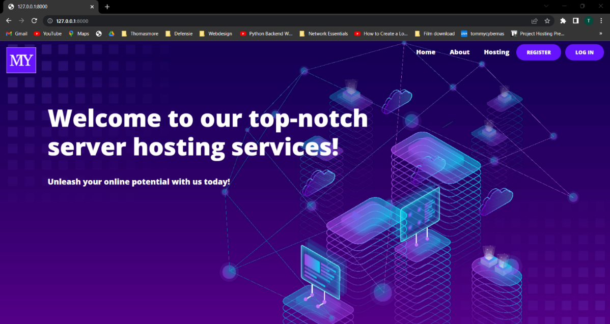

#### About page

On the about page we explain more about our company. Here you will also find the team members of our company and the contact details.

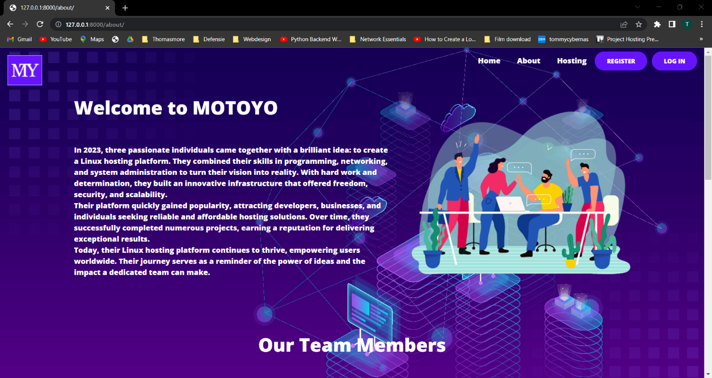

#### Hosting page

On the hosting page you can create a web hosting. Here you have the choice to choose between a “lamp” or “worldpress” hosting. Here you give the web hosting a hostname, username and a password to log in. After pressing the submit button, the web hosting is created. Messages will be displayed which 'url' you can use to access your hosting.

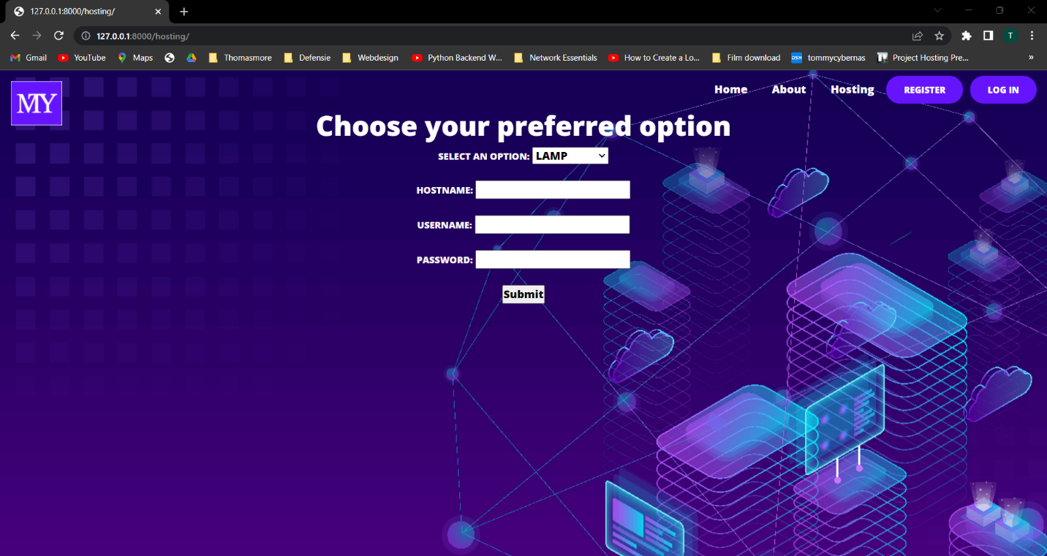

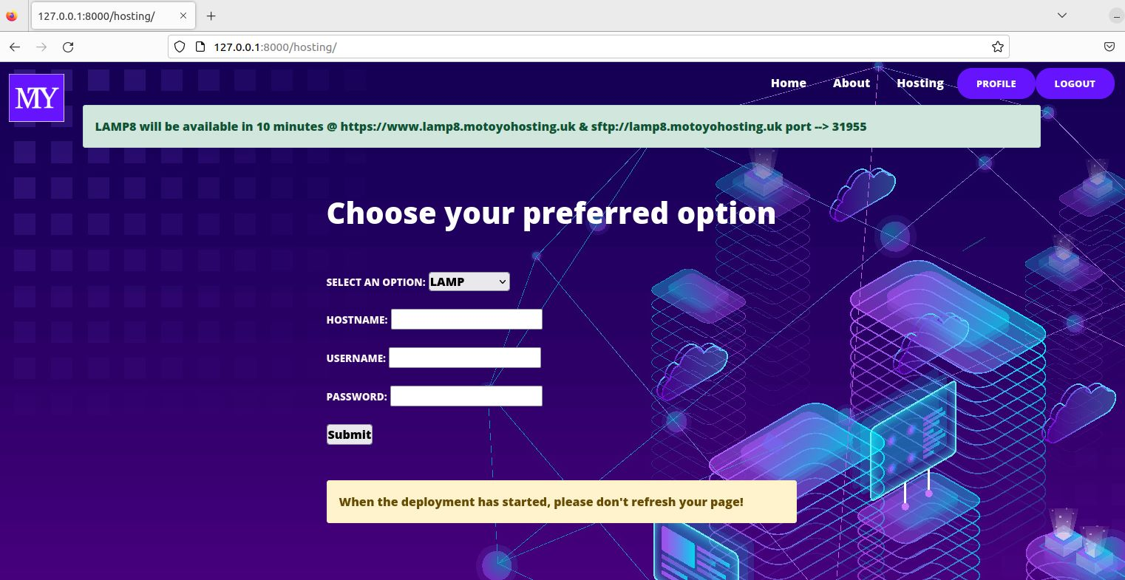

#### Register page

On the registration page, a user can register by means of a username, email and password. The Django framework will then check, by means of the built-in crispy form model, whether all requirements have been met and whether the username already exists. The framework also checks if the password is strong enough. After this, the user will be redirected to the home page where he will receive a message that he has been successfully registered.

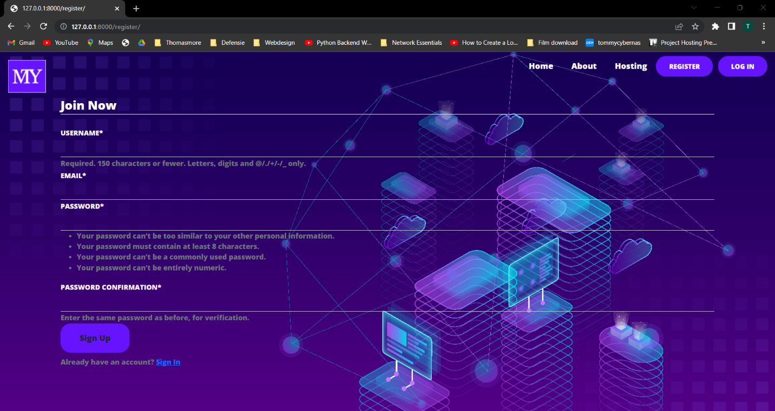

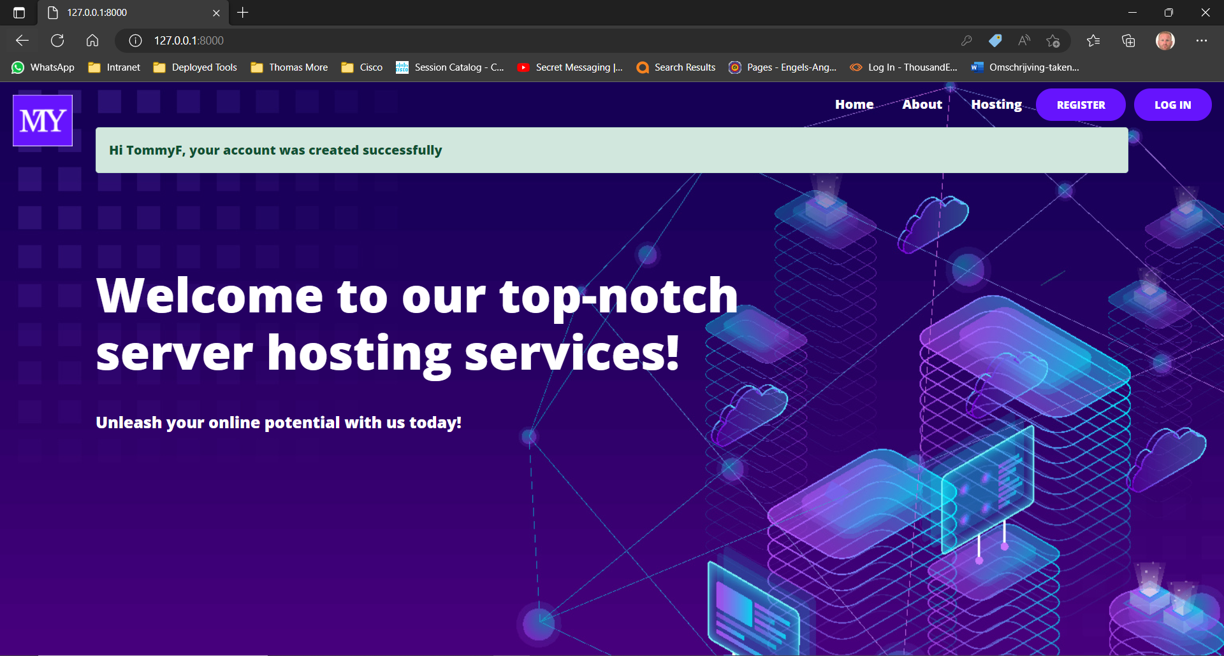

#### Login page

The user can log in on the login page using his username and password.

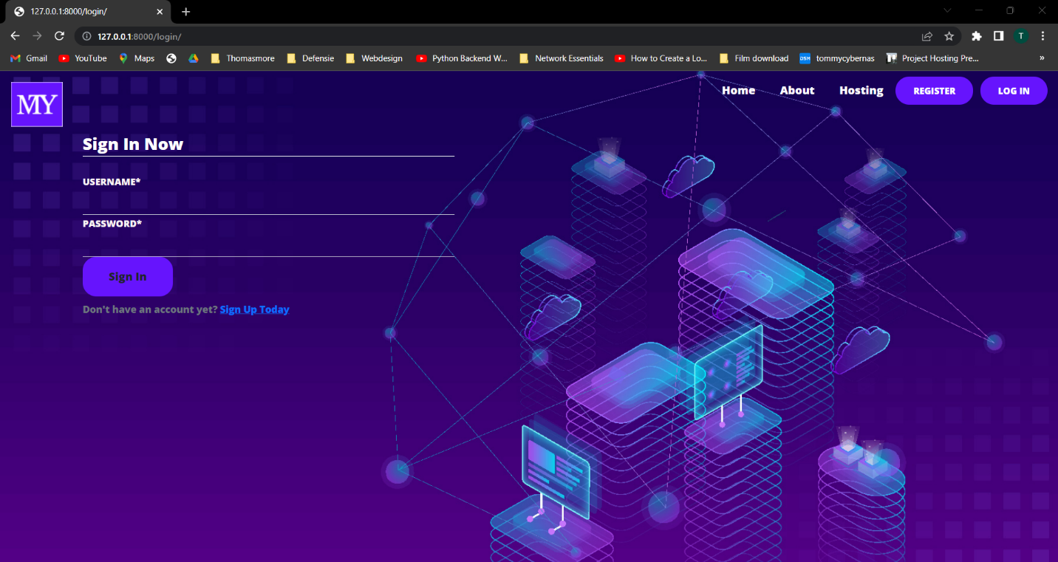

#### Profile page

On the profile page, the user can see under which credentials he or she is logged in.

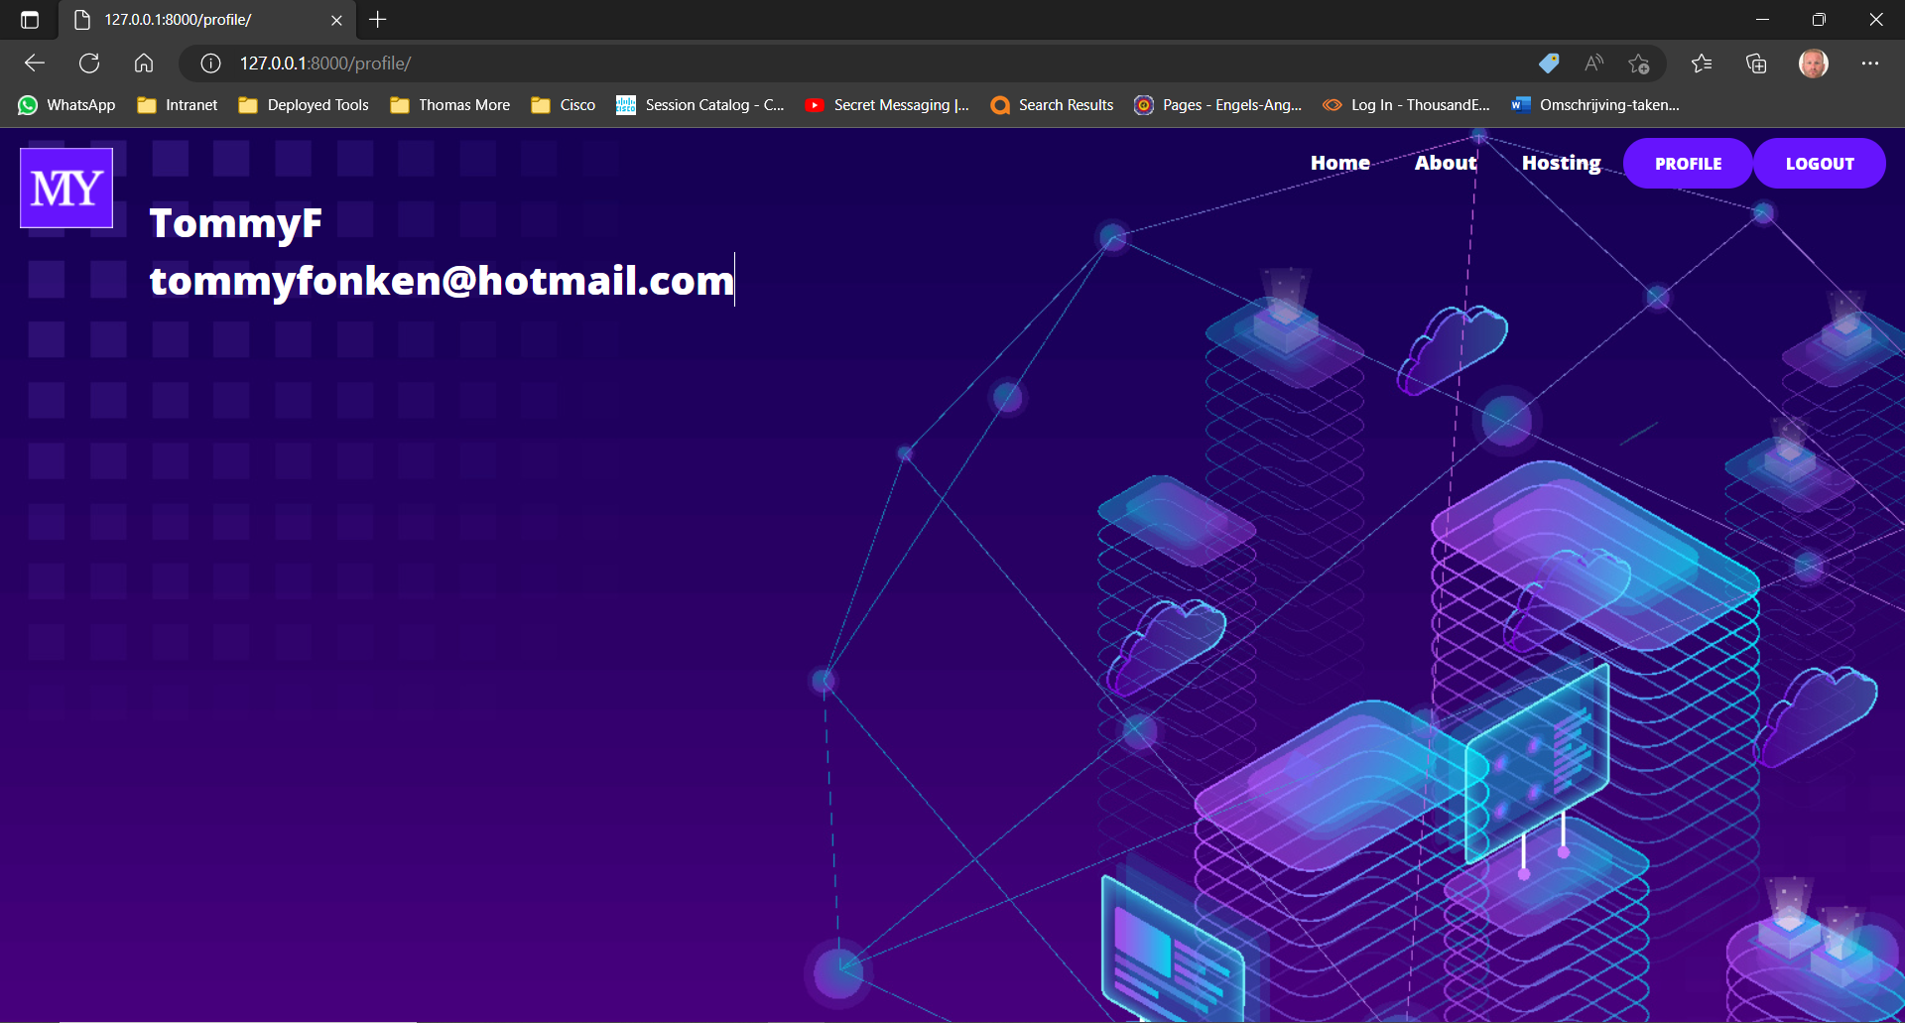

### Django Components

#### Template layer dynamic

Template Layer: Django's template layer enables the creation of dynamic and reusable web pages. It utilizes a syntax similar to HTML and allows developers to embed Python code to generate dynamic content. Templates help separate the presentation logic from the application's functionality. Here is an example of loading extern base templates in a different login template. On the top of the page u can see the dynamic tags. The advantage of the dynamic templates is that, if you want to display the same content over all pages, you only need to use one template. The dynamic tags injects all.

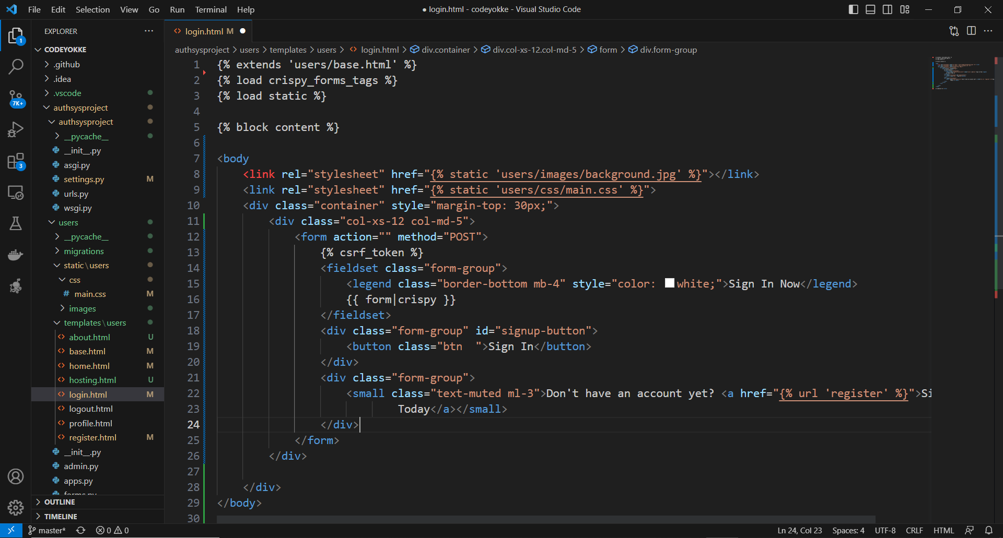

#### Model layer

Django's model layer provides a interface for interacting with databases. It allows us to define data models, create, retrieve, update, and delete records, and perform advanced queries. Django supports multiple databases, including PostgreSQL, MySQL, SQLite, and Oracle but we used the default database SQLite.

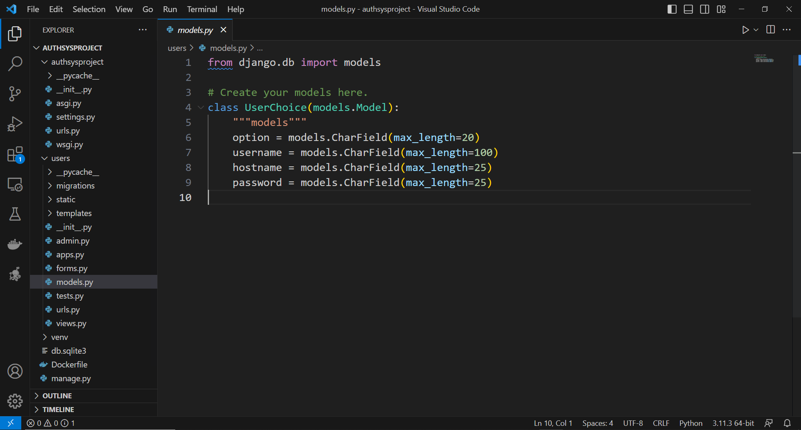

In the model.py file we have created a database in SQLite with the table name "UserChoice". The following attributes have been created in the table; “option”, “username”, “hostname” , “password”.

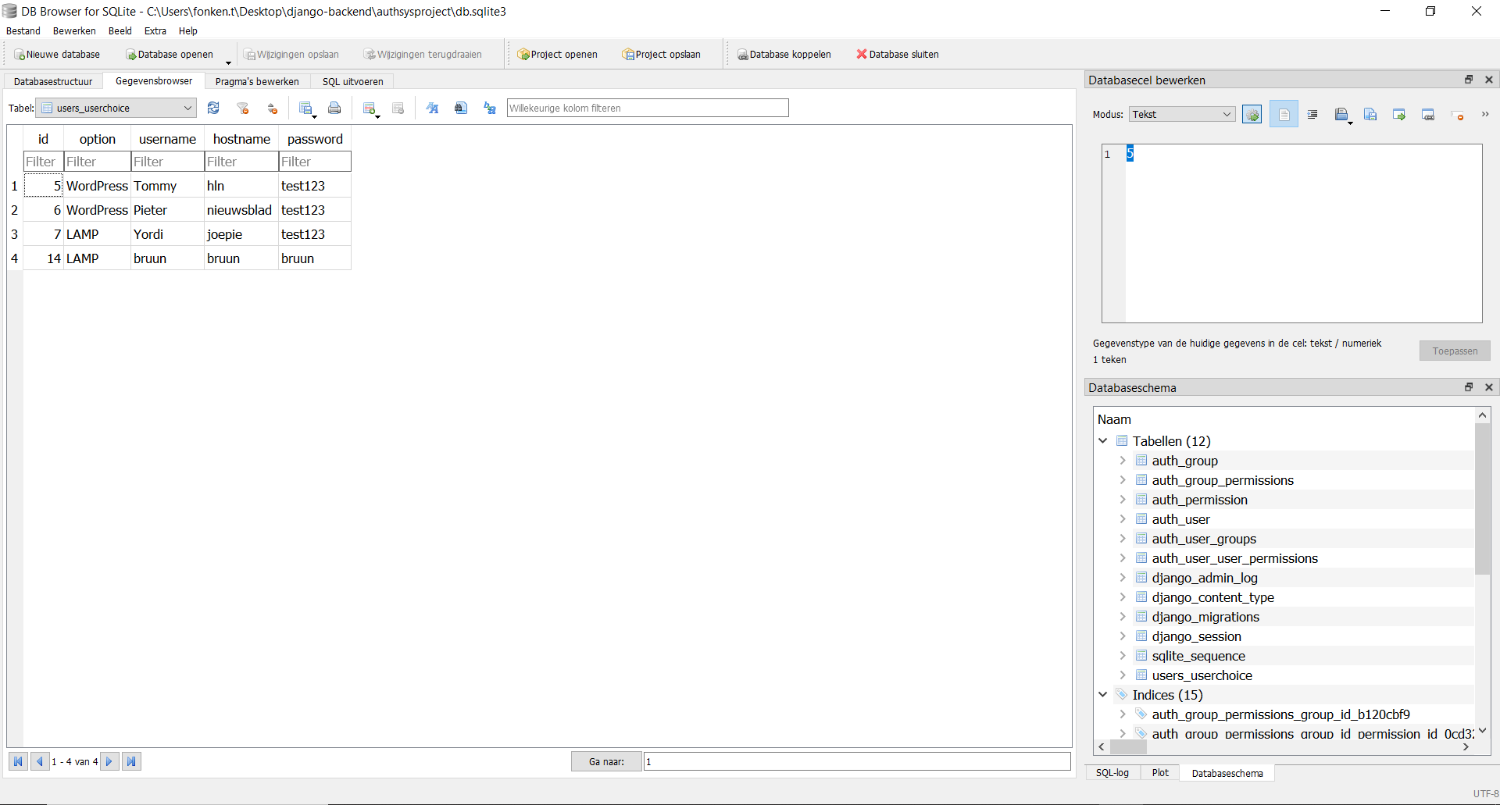Example of the created table in the GUI interface of QSLite's DB Browser.

#### View Layer

The view layer in Django handles the business logic of an application. It defines how data is presented to the user and handles user interactions. Views can be created as functions or classes, providing flexibility and allowing us to separate concerns effectively.

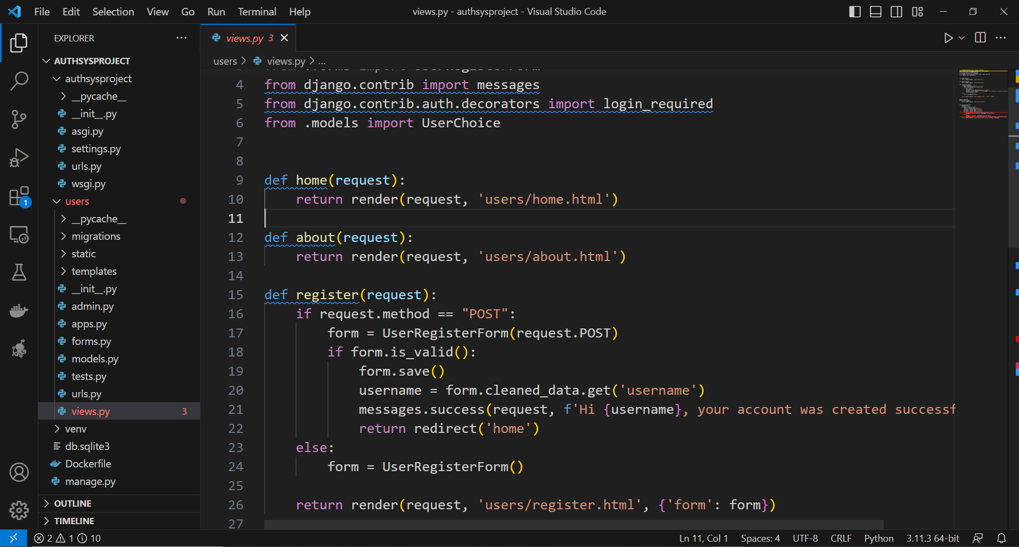

REMARK: In the example above, only the top of the file is visible. This file also runs the full API call script which contains about more than 2000 (!) lines of code.

#### URL Routing

URL routing is a crucial aspect of web development, and Django provides a powerful URL dispatching mechanism. It maps URLs to corresponding views, allowing developers to create clean and readable URLs for their applications. Django's URL routing simplifies the process of handling user requests and makes application maintenance easier.

First we map our "url" root folder in the django framework to our new project "url" folder.

Then we create a new folder "url.py" in our app folder and import the Django url path. Here we link the different urls paths in the file.

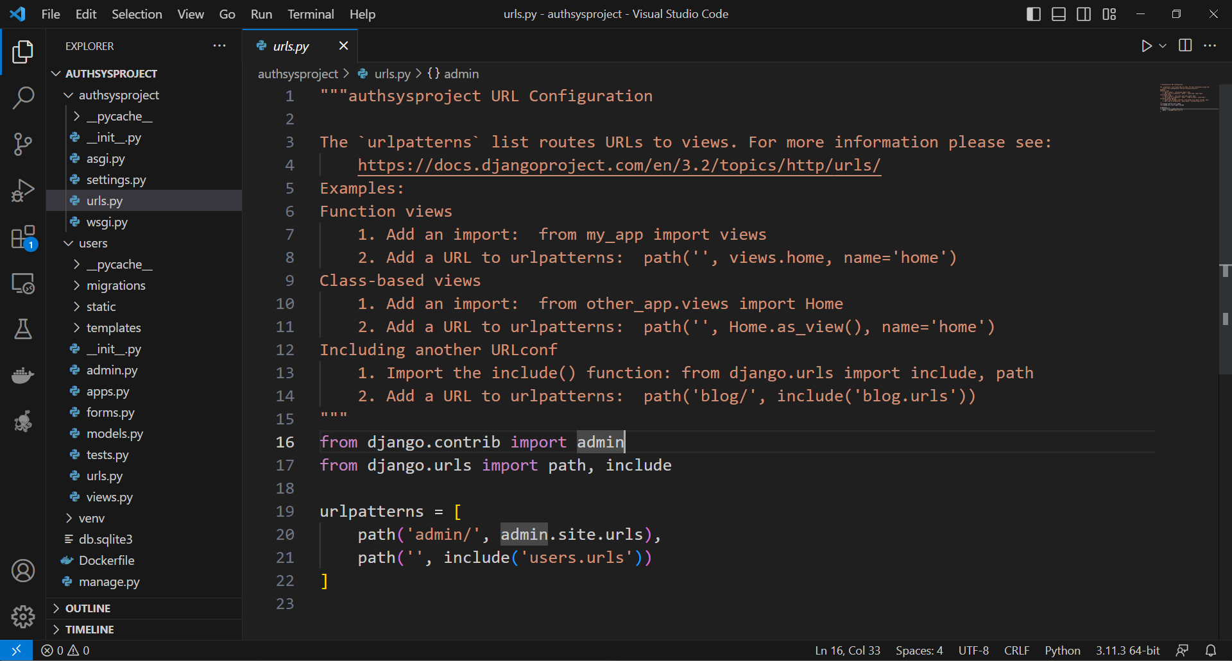

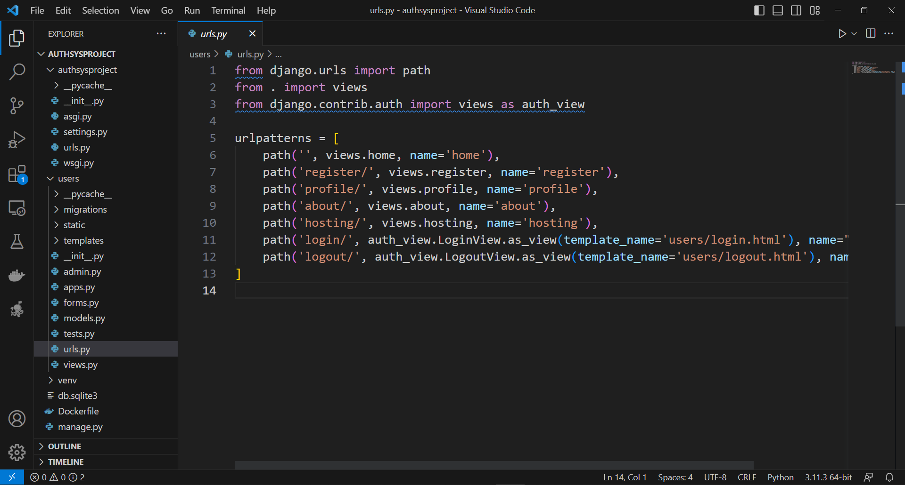

#### Setting file

The settings.py file is a crucial configuration file that resides in the project's main directory. It contains various settings and options that control the behavior of a Django project. The file include database configuration, internationalization options, time zone settings, static and media file paths, logging configurations, and more.

Here we have imported bootstrap and ‘crispyform’ for the registration form, this is a built in function in the Django framework, among other things like de database directory and so on.

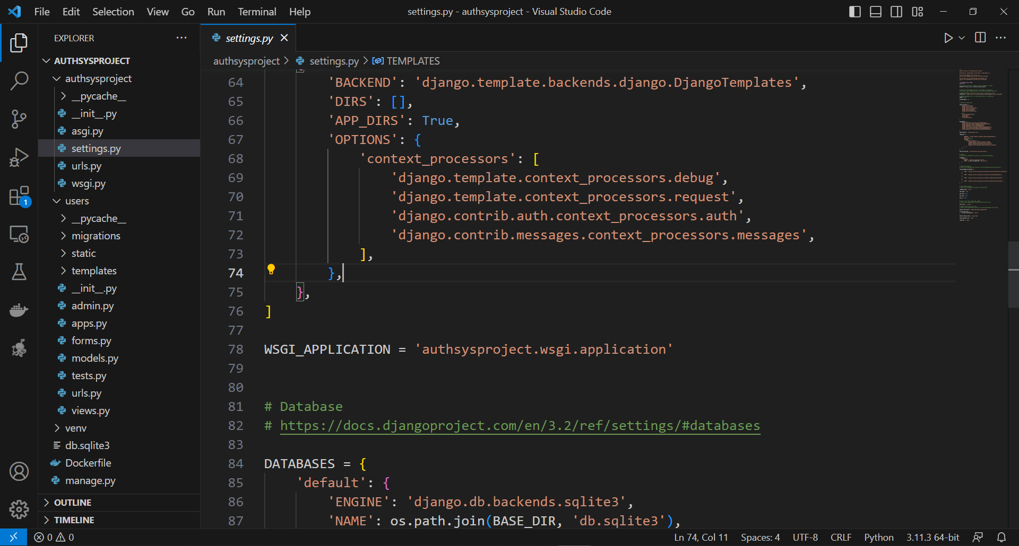

### Key Features used of Django

#### Admin Interface

Django's admin interface is a powerful tool that automatically generates a user-friendly interface for managing site content. It allows us to perform common administrative tasks, such as creating, editing, and deleting records, with minimal effort. The admin interface can be customized.

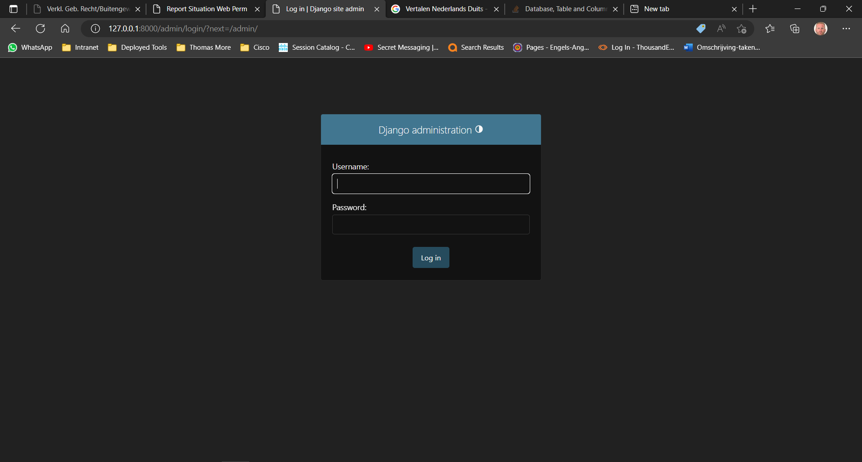

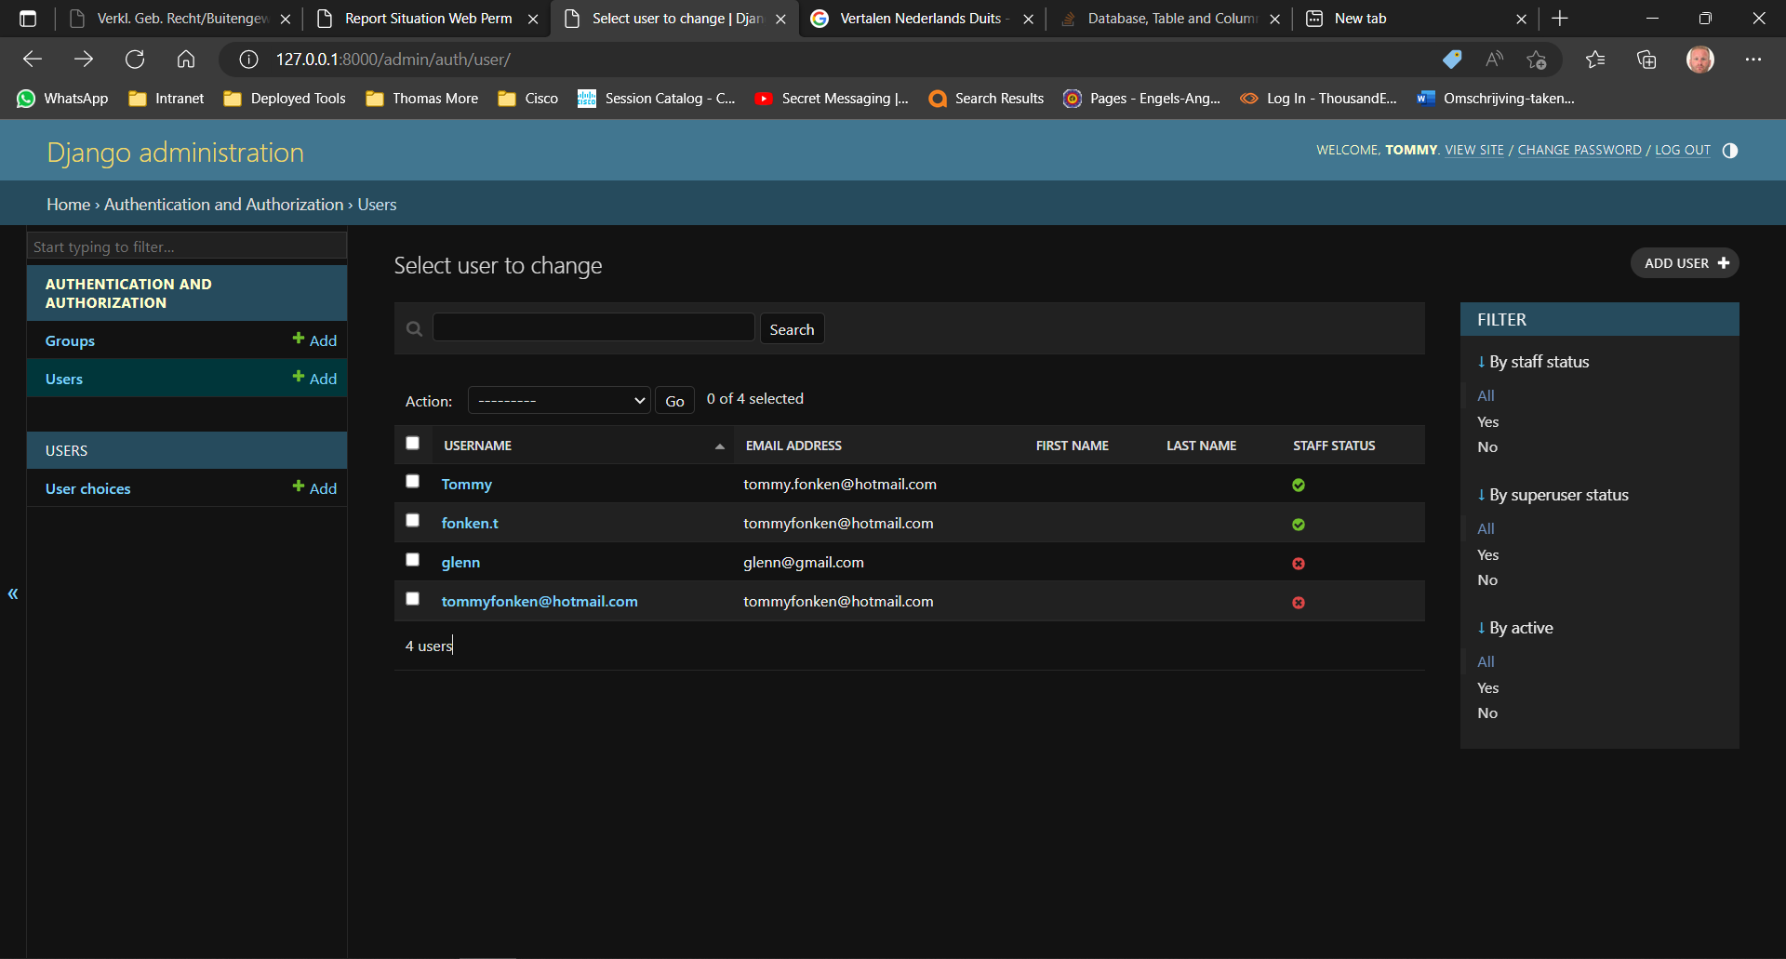

#### Authentication and Authorization

Django provides a robust authentication and authorization system out of the box. It supports various authentication methods, including username/password, social authentication, and integration with external authentication providers. We can easily manage user permissions and access control using Django's built-in functionality.

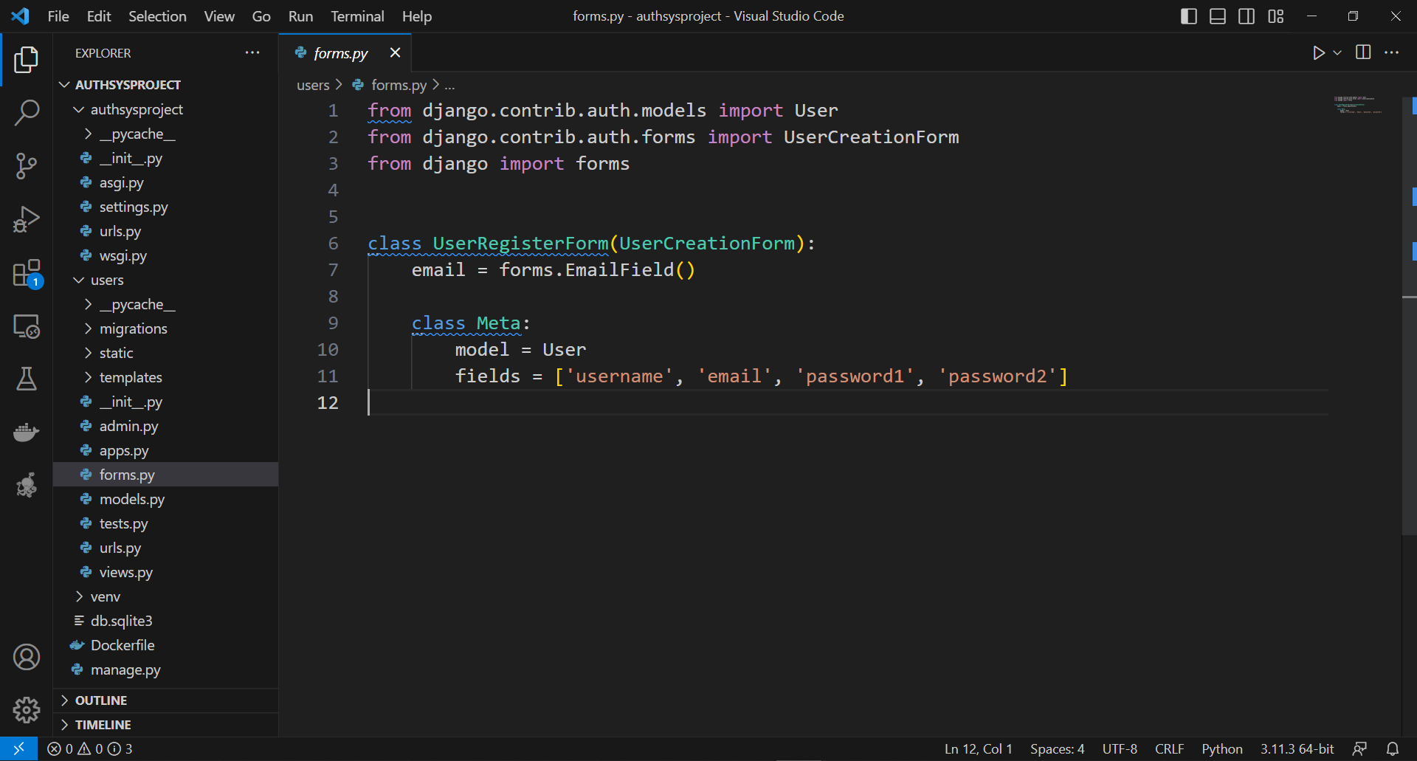

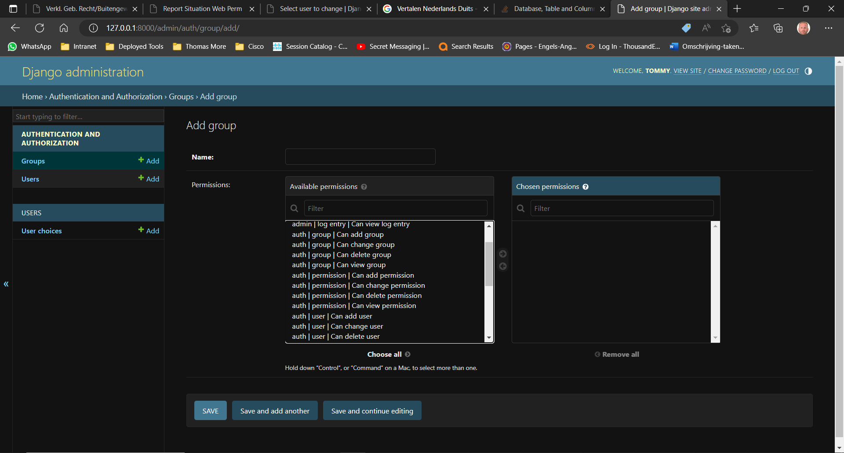

## Software

# Manual

# Troubleshooting

# tools

# Conclusion….

# Attachments

# Reference List